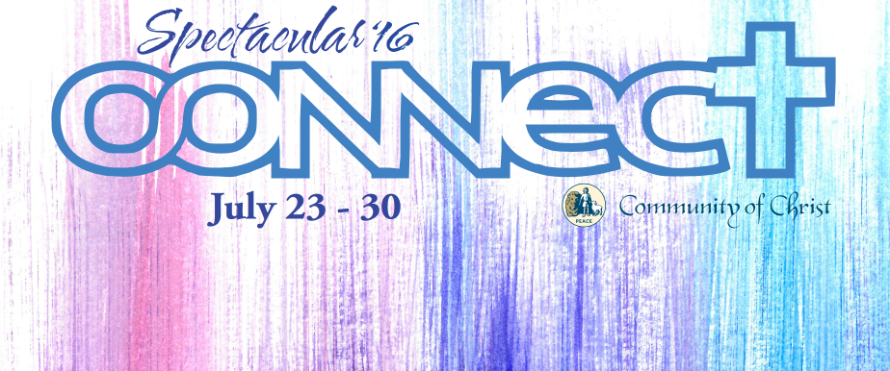
SPECTACULAR 2016

is fast approaching!

Looking to have the best week of your summer? Save July 23 to July 30

Approximately 1,100 high school campers and their leaders from all over the US and Canada will be at the Graceland University campus in Lamoni, Iowa for a week of fun, fellowship, and worship!

Participate in sports, art, music, theatre, quiz bowl!
There is something for everyone!!

Michigan Delegation - Spectacular 2016 Details

Spectacular is a world church sponsored event that is one of the best outreach avenues to the youth of the church. The mission of SPECTACULAR is to create a safe, Christ-centered community that encourages teenagers to discover God, their inherent worth, and cultivate and express their giftedness. It is a week filled with sports, service projects, concerts, corn dogs, tie-dying, disc golf, theatre, and adventures of all magnitudes. Last year there was a ferris wheel, fireworks, and professional snow boarder -- I can't even dream up what will happen this year!

Who can attend: Spectacular is available to youth who have completed 9th grade through 12th grade in June 2016.

Registration: To register for Spectacular, each camper must fill out a registration form and consent form agreeing to the Spectacular code of conduct. This form must be signed by parents or legal guardians, as well. These forms, a copy of a current health insurance card, and registration money must be sent to the delegation registrar (address below) by June 1st, 2016. All registrations must be done through the delegation since Spectacular does not accept individual registrations.
Registration forms can be found at: http://spec-cofchrist.org/register/

Cost: $360 per camper – This covers the Spectacular registration, transportation by bus to Graceland and back, and other costs such as 2 delegation shirts, laundry, etc. Note: If more than one sibling is attending Spectacular there will be a $50 discount for each additional camper in the same family.

Invite a Friend! Campers can offer their friend(s) a $50 discount off the SPEC registration fee. This offer is only for SPEC campers that are coming for the first time because they were invited by a friend who will also be attending as a camper.

Staff: Please also complete the Staff Spectacular registration form and return it to the registrar by 6/01/2015. Staff registration fee is $225 to cover the Spectacular registration and transportation costs.

Please send registrations or direct questions to the delegation leader/registrar:

Alicia Pearson Registration Checklist
3375 Oconto Ct SW
Grandville, Mi 49418 Signed Registration Form & Consent Form
(616) 634-3305
aliciaclorepearson@gmail.com Copy of Medical Insurance Card
*Also, feel free to find me on Facebook!
Registration Fee (payable to Community of Christ)
Mail by 6/1/2016

SPECTACULAR PACKING LIST

Personal Items

- Warm Weather Clothes**
- Cool Weather Clothes **
- Dress(ier) Outfit (if applying for Scholarships/Performing)
- Towels/wash cloth
- Deodorant/Toiletries
- Bedding/Pillow (dorm beds are twin-size)
- Indoor Athletic Shoes (for gym competitions)
- Outdoor athletic shoes (for outdoor competition)
- Athletic Shorts/Pants
- Swimsuit
- Ladies - Feminine Personal Supplies
- Water Bottle
- Sunscreen
- Sunglasses
- Backpack/Carry-on Bag (for the bus)
- Personal Sports Equipment (e.g. cleats, shin guards, tennis racket, etc)
**We have our own delegation soccer balls, basketballs, volleyballs, bats, etc.
- Instruments/Music (if you plan to participate in worship or performances)
- Fan (dorm rooms do not have AC)
- Spending money:
Necessary - money for 3 meals en route (breakfast/lunch on the way; dinner back -- $20ish)
Optional - money for snacks, offertories, Graceland Bookstore, concert CDs/t-shirts

Leave at home: Expensive electronics (i.e. personal computers, tablets, etc), large amounts of cash, excessive amounts of clothes -- delegation shirts will be provided and worn every day.

If you have a movie request for the bus please send the title to the delegation leader before departure.

- PARENTS CALLING CAMPERS - You are welcome to stay in contact with your camper throughout the week, but please know that campers will be extremely busy and will have many times throughout the day where they will not have the ability to answer or return calls/texts (sports games, classes, worships, etc). If you need to contact your camper immediately, please feel free to call the cell phone of Alicia Pearson (616) 634-3305 and we will pass the message on to your camper.

- PLEASE PACK LIGHTLY! Each camper should only bring ONE large piece of luggage to stow and ONE carry-on bag for the bus.

The theme for SPECTACULAR 2016 is “Connect”. If you have testimonies to share, stories about being in action for Christ, want to share in some form of worship, or are a priesthood member, please let us know prior to leaving for SPEC.

